

**REQUIREMENTS DOCUMENT**

**Serdachny Hockey iOS Mobile App**

**Abstract**

This document provides an overview of the

Prime Software

University of Regina

2020

**VERSION HISTORY**

|  |  |  |  |
| --- | --- | --- | --- |
| **Version** | **Description of Change** | **Author** | **Date** |
| 1 | Document Creation | *McKenzie Busenius* | 01/26/2020 |
| 1.1 | Document Revision | *McKenzie Busenius* | 02/03/2020 |
| 1.2 | Document Revision | *Jiahao Li* | 04/04/2020 |
|  |  |  |  |
|  |  |  |  |
|  |  |  |  |

**** Edit Color ****

Mckenzie Busenius - Black

Jinkai Fan - Red

Jiahao Li - Green

CONTENTS

**INTRODUCTION** **3**

Purpose 4

Scope 4

Background 4

References 4

Assumptions and Constraints 4

METHODOLOGY 5

**FUNCTIONAL REQUIREMENTS** **7**

**Context** **7**

User Requirements 9

Data Flow Diagrams 10

Logical Data Model/Data Dictionary 10

Functional Requirements 11

Functional Requirements Group 1 11

Functional Requirements Group 2 11

Functional Requirements Group 3 11

Functional Requirements Group 4 11

**OTHER REQUIREMENTS** **12**

Interface Requirements 13

Hardware/Software Requirements 14

Operational Requirements 14

Security and Privacy 15

**APPENDIX A - GLOSSARY** **15**

# INTRODUCTION

[Provide an overview of the system and some additional information to place the system in context.]

This project is in partnership with Serdachny Hockey under the direction of Steve Serdachny. The application is an iOS based mobile management system to upgrade the current redundant system

## Purpose

This document is overview of the system design and the breakdown of the design decisions. Throughout this document is the flow of

## Scope

This document is intended to provide a road map for the design and implantation requirements for development of the IOS application.

## Background

Prime Software is an engineering group based at the University of Regina. The formation of Prime Software was for the primary object of completing ENSE 477 an engineering capstone project. Our primary objective was to design, implement and deploy working software for the customer Serdachny Hockey and Power Skating based out of Edmonton, Alberta Canada. The document was constructed by McKenzie Busenius, Jiahao Li, Jinkai Fan. We are producing this document for the purpose of explain the overall requirements for the App

## Assumptions and Constraints

[Provide a list of contractual or task level assumptions and/or constraints that are preconditions to preparation of the FRD. Assumptions are future situations beyond the control of the project, whose outcomes influence the success of a project.]

The assumptions for this project are as follows:

1. Proprietary software for Serdachny Hockey

The Constraints for this project are as follows:

1. Learning the software for the first time
   1. XCode, Swift, AWS(Amazon Web Services)
2. Legal Restrictions for handling user data
   1. Personal Information
   2. Video/ Photo
3. MVP #1 Deliverable by April 4th, 2020

## METHODOLOGY

[Describe the overall approach used in the determination of the FRD contents. Describe the modeling method(s) so non-technical readers can understand what they are conveying.]

The general approach to the IOS application for Serdachny Hockey by Prime Software was to create a system that could easily be inserted into normal day to day operations. The chosen design approach was an Agile Design Method which consists of multiple intervals of planning, design, testing, and releases. Where the primary focus was iterations and determining the structure of MVP’s (Minimum viable product).

# FUNCTIONAL REQUIREMENTS

# Context

[Provide a context diagram of the system, with explanations as applicable. The context of a system refers to the connections and relationships between the system and its environment.]

Home Screen Context Diagram

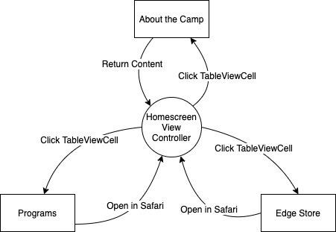

Media Screen Context Diagram

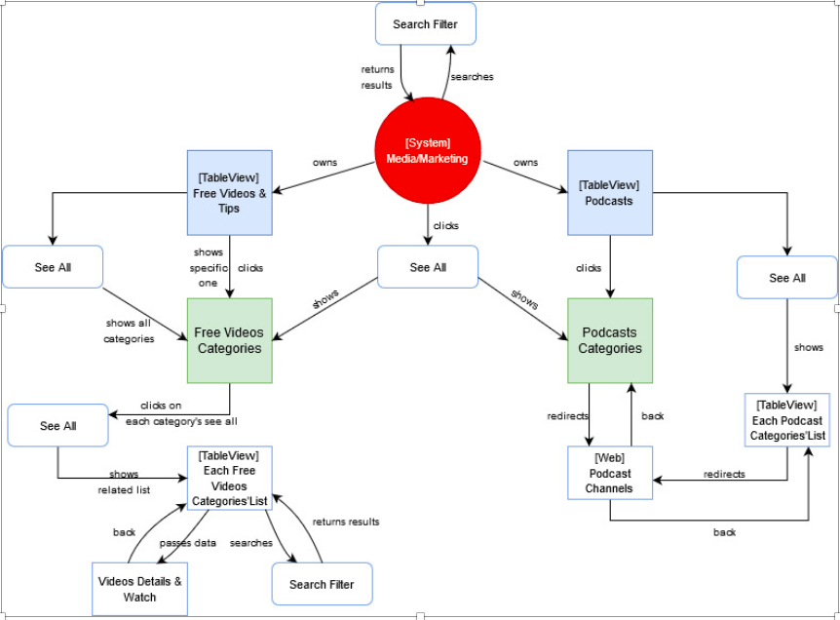

Account Screen Context Diagram

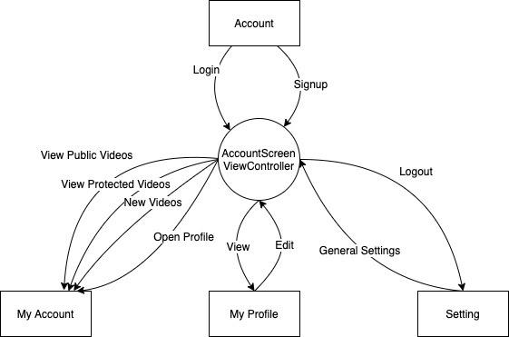

Contact Screen Context Diagram

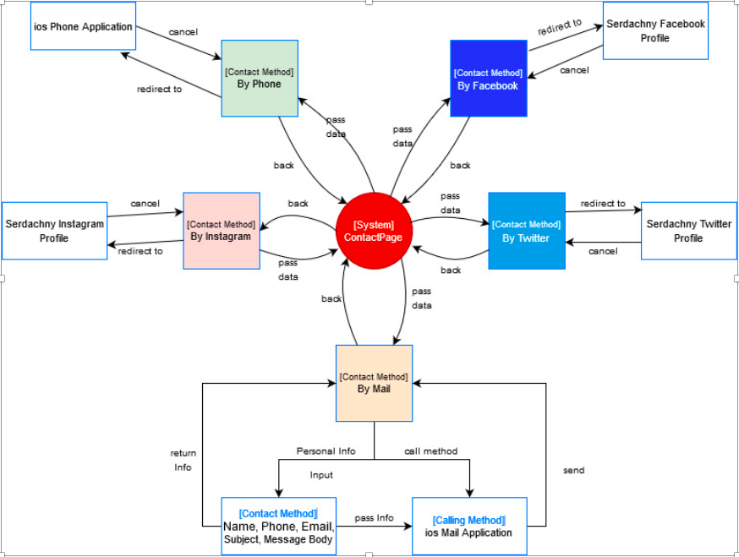

## User Requirements

Home Screen

|  |  |
| --- | --- |
| **[Req #]** | **Title** |
| Req #1 | The application shall allow the user to view the introduction of the camp. |
| Req #2 | The application shall allow the user to view the programs provided by the camp. |
| Req #3 | The application shall allow the user to purchase the items sold by the camp. |

Media Screen

|  |  |
| --- | --- |
| **[Req #]** | **Title** |
| Req #1 | The application shall allow the user to browse the free videos & podcasts |
| Req #2 | The application shall allow the user to click the video contents for viewing the details or watching videos. |
| Req #3 | The application shall allow the user to view all videos & podcasts category |

Account Screen

|  |  |
| --- | --- |
| **[Req #]** | **Title** |
| Req #1 | The application shall allow the user to create a new account. |
| Req #2 | The application shall allow the user to login using the created account. |
| Req #3 | The application shall allow the logged in user to view and modify the profile. e.g., avatar, name, ID, etc. |
| Req #4 | The application shall allow the logged in user to view the public video category. |
| Req #5 | The application shall allow the logged in user to view the protected video category. |
| Req #6 | The application shall allow the logged in user to post new videos. |
| Req #7 | The application shall allow the user to go to setting menu. |
| Req #8 | The application shall allow the logged in user to log out the current account via setting menu. |

Contact Screen

|  |  |
| --- | --- |
| **[Req #]** | **Title** |
| Req #1 | The application shall allow the user to view the contact information of the camp |
| Req #2 | The application shall allow the user to contact the camp or leave feedback message |

## Data Flow Diagrams

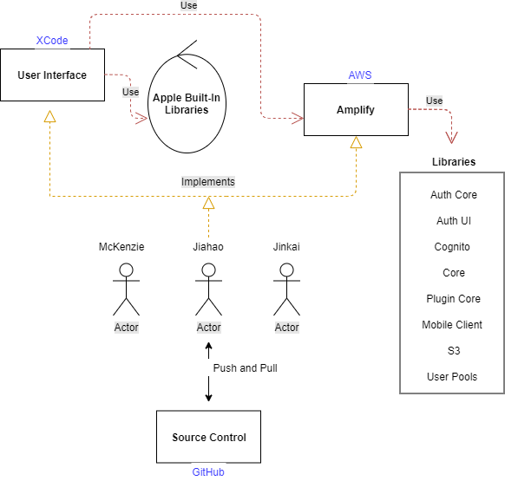

## 

## Functional Requirements

1. Group 1 – Homepage
2. Group 2 – Media/ Marketing
3. Group 3 – Account
4. Group 4 – Contact

### Functional Requirements Group 1

Refer to external documentation:

1. User Story Map Excel Package
   1. USM Homepage
2. Functionality Excel Package
   1. Functional Document
3. AWS (Amazon Web Services) Excel Package
   1. AWS Document

### Functional Requirements Group 2

Refer to external documentation:

1. User Story Map Excel Package
   1. USM Media/ Marketing
2. Functionality Excel Package
   1. Functional Document
3. AWS (Amazon Web Services) Excel Package
   1. AWS Document

### Functional Requirements Group 3

Refer to external documentation:

1. User Story Map Excel Package
   1. USM Account
2. Functionality Excel Package
   1. Functional Document
3. AWS (Amazon Web Services) Excel Package
   1. AWS Document

### Functional Requirements Group 4

Refer to external documentation:

1. User Story Map Excel Package
   1. USM Contact
2. Functionality Excel Package
   1. Functional Document
3. AWS (Amazon Web Services) Excel Package
   1. AWS Document

# OTHER REQUIREMENTS

[Describe the non-behavioral requirements.]

Home Screen

|  |  |
| --- | --- |
| [Req #] | Title |
| Req #1 | The “Program Table View” shall ensure that the program info can be retrieved from program array. |
| Req #2 | Users shall be directed to the corresponding program detail web page by clicking the program cells. |
| Req #3 | The “Edge Store Table View” shall ensure that the item info can be retrieved from edge store array. |
| Req #4 | Users shall be directed to the corresponding item detail web page by clicking the item cells. |

Media Screen

|  |  |
| --- | --- |
| [Req #] | Title |
| Req #1 | The “Free Video Table View” shall ensure that the program info can be retrieved from different video category array. |
| Req #2 | Users shall be directed to the corresponding video details page by clicking the video cells. |
| Req #3 | Users shall be directed to the corresponding podcast detail page by clicking the podcast cells. |

Account Screen

|  |  |
| --- | --- |
| [Req #] | Title |
| Req #1 | The AWS Authentication system shall ensure the user can create new account. |
| Req #2 | The AWS Authentication system shall ensure the user can log in to the application. |
| Req #3 | Only logged in user can retrieve the videos from from AWS S3 bucket. |
| Req #4 | Only logged in user can modify the profiles. |
| Req #5 | About the camp view visible on the home screen. |

Contact Screen

|  |  |
| --- | --- |
| [Req #] | Title |
| Req #1 | The “Contact Static View” shall ensure that the camp info(at least email contact) can be display from view. |
| Req #2 | Users shall be able to contact company in specific ways |

## Interface Requirements

[Describe the user interfaces that are to be implemented by the system.]

Home Screen

|  |  |
| --- | --- |
| [Req #] | Title |
| Req #1 | List of programs visible in the program table view. |
| Req #2 | List of store items visible in the edge store table view. |
| Req #3 | Table cell item clickable. |
| Req #4 | About the camp view is clickable on the home screen. |
| Req #5 | About the camp view visible on the home screen. |

Media Screen

|  |  |
| --- | --- |
| [Req #] | Title |
| Req #1 | List of videos and podcasts visible in the table view. |
| Req #2 | Table cell item clickable. |
| Req #3 | Details of each content should be passed to other views |
| Req #4 | Free videos can be watched in the view |
| Req #5 | Enable search filter for videos |

My Account

|  |  |
| --- | --- |
| [Req #] | Title |
| Req #1 | Login and Signup Button |
| Req #2 | Visualize the login and signup form, ensure the user has access to the form. |
| Req #3 | Button for login |
| Req #4 | Button for signup |
| Req #5 | Button for change the password |

Contact Screen

|  |  |
| --- | --- |
| [Req #] | Title |
| Req #1 | Camp contact info visible |
| Req #2 | Optional ways to contact camp |
| Req #3 | Contact methods clickable. |

## Hardware/Software Requirements

[Provide a description of the hardware and software platforms needed to support the system.]

The hardware needed to use the app is any Apple Mobile device such as Iphone or Ipad. Currently the system is backward compatible to the Iphone 4 model. Along with using an Apple product the software used for the system will be available on the App store for public download.

## Operational Requirements

[Provide the operational requirements in this section.

Do not state how these requirements will be satisfied. For example, in the Reliability section, answer the question, “How reliable must the system be”? Do not state what steps will be taken to provide reliability.

Distinguish preferences from requirements. Requirements are based on business needs, preferences are not. If, for example, the user requires a special response but does not have a business-related reason for it, that requirement is a preference.

Other applicable requirements on system attributes may be added to the list of subsections below.]

Operational requirements describe how the system will run and communicate with operations personnel.

The system is intended to scale with the user rate of use. This means as the number of users increases the system must accommodate the growth. The overall reliability of the system must provide seamless functionality for users due to the real time analysis of an individual's training progression.

### Security and Privacy

A. The consequences of security breaches for the application must be at all cost be avoided:

1. Loss or corruption of data
2. Disclosure of secrets or sensitive information
3. Disclosure of privileged/privacy information about individuals
4. Corruption of software or introduction of malware, such as viruses
5. The type(s) of security required. Include the need for the following as appropriate:
6. Physical security.
7. Access by user role or types.
8. All users have permission to view the homescreen, media, and contact section but not update it.
9. All users (once created an account) will have access to view, update, and delete personal data, but not others.
10. Company administrators have the ability to create, edit and remove all users information on a case by case basis.
11. There is a need for certification and accreditation of all security measures that ownership must grant.

# APPENDIX A - GLOSSARY

[Define terms, acronyms, and abbreviations used in the FRD.]